African American and Latinx History Course Syllabus - 2019-2020
Ms. Nataliya // nataliyabraginsky@gmail.com
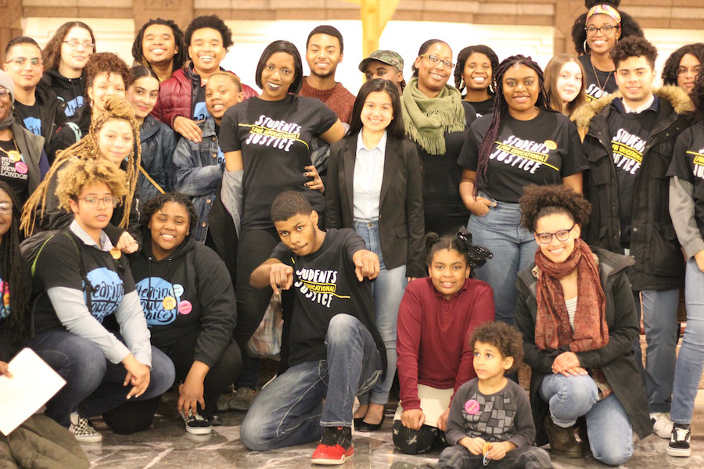
This course is a product of history, and it is youth of color who made this history possible! In the photo to the right you can see some of the local high school students who testified before the Connecticut State Legislature, convincing our representatives to pass a bill which mandates that all high schools in our state offer an African American and Latinx History course. While this law does not officially go into effect until the 2022-2023 school year, our school decided that we would not wait -- that this class has long been overdue!

This class will take a critical race theory approach to examining the history and present day realities of racism and white supremacy, and their impacts on Black and Latinx people -- and more importantly, the ongoing resistance to these forms of domination. While oppression is a part of this history, it is not the centerpiece. That is, African American and Latinx people have made the U.S. what it is, contributing untold physical and intellectual labor and creative genius. Furthermore, the roots of Black and Latinx legacies precede the very existence of the United States: in Africa, the cradle of civilization, and throughout the Americas where Indigenous people have thrived for thousands of years. Looking back while also looking forward, this class recognizes that African American and Latinx people, history, and culture have a lot to teach us about how to radically reimagine new possibilities and more just futures.

Curriculum Essential Questions:
- Who and what are the diverse people, places, and time periods that African American and Latinx history cover? What are the stories of the African and Latinx diaspora?
- In what ways are Indigenous, Black, and Latinx histories intertwined?
- What does African American and Latinx history reveal about the United States, its foundation, and how power is structured today?
- How have Black and Latinx Americans — both voluntarily and by force —shaped the U.S.?
- How have Black and Latinx people fought for freedom and justice throughout history and today, and in what ways have their struggles been in solidarity with various other groups?
- What do the themes of borderlands and mestizaje, which are central to Latinx history, teach us about the country, the world, and ourselves?
- What are the unrealized possibilities of Reconstruction? What impact does the period of Reconstruction have on our country today?
- What do Black and Latinx people, history, and culture teach us about radically reimagining new possibilities and more just futures?

Unit | Description | Assignments and Dates
Unit 1: What’s in a name? | Language matters, so for this first unit we will analyze the various terms used to label Black and Latinx people, and how they have changed over time. Students will have a small group debate about which terms are most fitting for the communities they claim to represent. | S.A.C. (Debate)  9/3 - 9/13
Unit 2:  Africa and Indigenous Latin America | The history of African American and Latinx people begins with the powerful civilizations of Africa and Latin America. We will analyze their cultures and histories, as well as their resistance to enslavement and colonization. | Analysis: Museum Exhibit  9/16 - 9/27
Unit 3: Abolition, Independence, and Revolution | As soon as slavery began in the U.S., Africans and African Americans were fighting for emancipation. At the same time, in Central and South America, Indigenous and Latinx people were fighting for independence from Spain, and later for revolution. We will examine these struggles, and their intersections. | Role Play: Mexican American War  10/21 - 11/15
Unit 4: Moving Borders / Moving Across Borders | Not only have Latinx people long been crossing borders to safety, but also borders have been crossing them, changing their government, their national identity, and their citizenship status without their consent. The popular saying amongst Chicanos is: “We didn’t cross the border; the border crossed us.” This will be a theme for this unit. | Creative Project and Exhibition  11/18 - 12/20
Unit 5: Reconstruction and Black Excellence | The period after emancipation, known as Reconstruction, has played a huge role in the state of our country today. It was a time of contradictions, of progress and backlash. In the face of newfound emancipation and ongoing struggles for freedom, it was also a time of black excellence. This unit will be an examination of that. | A People’s History of Black and Latinx New Haven Map Project  1/2 - 2/14
Unit 6: Legacies of Resistance Research Paper | We will conclude this course by researching the legacies of resistance of Black and Latinx people. Students will choose from a long list of topics, each selecting a different form of resistance to research, write about, and share with their peers. Research papers will be 6-8 pages, including at least 6 sources, and will be shared in a presentation at our school’s fourth annual Social Justice Symposium on May 22nd! | College Level Research Paper and Social Justice Symposium Presentation  2/24 - 5/22

Assignments | Description | Percentage
Projects | This class is project-based, and each of the above units concludes with a project, culminating in our largest project, a college level research paper and presentation, which we will work on throughout the third trimester. | 50%
Core Questions | Core questions guide the day’s lesson. Students will answer the questions at the end of class to demonstrate their understanding and critical thinking skills. | 20%
Class Discussion and Classwork | Class discussions will be a significant element of this class, and will be supported by daily classwork. Regular participation is essential for doing well in the class, and for preparing for college and/or career. | 20%
Opener Facilitation | Openers will focus on historic figures, and each student must facilitate one: researching an inspiring Black and/or Latinx person (a list will be provided), educating your classmates about them through facts and quotes, and leading peers in a brief class discussion, providing a thoughtful guiding question. | 10%
**You will need a single subject notebook and folder (which will be kept in the classroom), as well as pens/pencils**

